BUSY BEE MEDIA
FOR IMMEDIATE RELEASE
Contact: Rachel Jackson
Phone: Upon request
Email: hello@busybeemedia.org
https://busybeemedia.org/racheljackson/
Media kit: https://busybeemedia.org/media-kit-just-kids

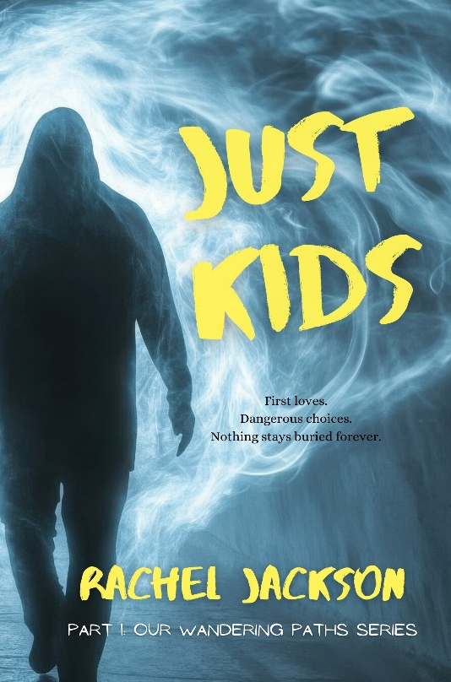
SOME FIRST LOVES NEVER LET YOU GO.
SOME MISTAKES DON’T STAY IN THE PAST.
North London, 1998.
Sixteen-year-old Sarah Page is on the edge of adulthood—caught between exam pressure, fractured families, and the dangerous pull of wanting more from life.
When she meets Nick, the connection is instant, electric, and destabilising. He feels like freedom. Like possibility. Like the person she’s been waiting for.
But lurking at the edges of Sarah’s world are temptations, dangerous loyalties, and men who don’t understand boundaries. As parties blur into threats, and attraction shades into obsession, Sarah is forced to confront how quickly excitement can tip into danger—and how hard it is to tell the difference when you’re young, flattered, and looking for somewhere to belong.
Then there’s Andy—watchful, complicated, and impossible to read. A source of safety… or another risk entirely.
As Sarah navigates friendship, first loves, and the pressure to grow up before she’s ready, she learns that survival isn’t just about escaping harm—it’s about recognising it in time.
Just Kids is a tense, emotionally grounded coming-of-age novel about desire, power, and the moments that shape us long before we understand what they mean. Blending romance with psychological suspense, it explores the dangerous grey areas of youth — where love, fear, and longing collide.
Because some stories don’t end when you walk away.
They wait.
Just Kids, part one of the Our Wandering Paths series, is available to buy now on Amazon.
###

If you would like more information about author Rachel Jackson and Just Kids, please contact Rachel Jackson at hello@busybeemedia.org. A Media kit is available at: https://busybeemedia.org/media-kit-just-kids

